INTRODUCTION
Overview
Vehicle Management is an application where a customer Details are stored in order to choose cars, bikes and commercial vehicles for travel within the city. The data which is stored here is further used to remind them if any offers are provided during the seasons and any updates regarding vehicles are sent to them in the form of messages and mails
A brief description about our project
A vehicle management project is a system or application that is used to track and manage a fleet of vehicles. It might be used by a company with a large number of vehicles, such as a rental car
company or a transportation company, to keep track of vehicle maintenance, availability, and usage
Purpose
This Project helps for place the order to purchase cars, bikes and commercial vehicles.
The use of this project. What can be achieved using this.
- It might be used by a company with a large number of vehicles, such as a rental car
company or a transportation company, to keep track of vehicle maintenance, availability, and usage
- It is used to customer to place the order of vehicles

- Problem Definition & Design Thinking
Empathy Map
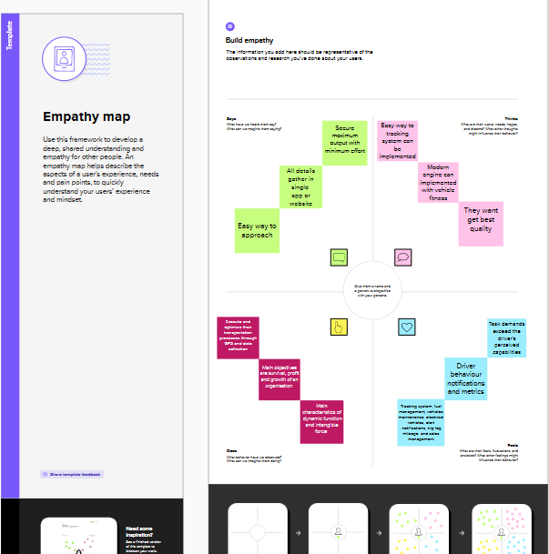
Ideation & Brainstorming Map

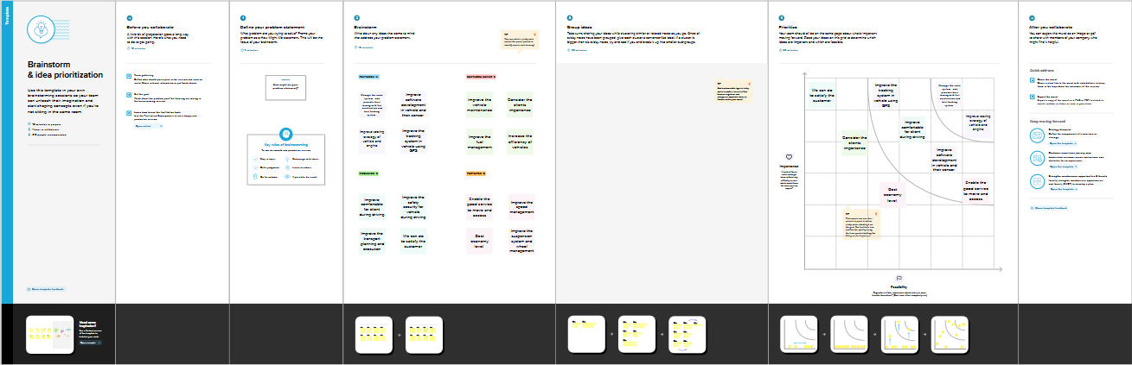

RESULT

Data Model:
Field label | Data type
2 wheeler/4 wheeler | Picklist
Hero/Honda/TVS | Picklist

Object name | Fields in the Object
obj1
Vehicle
obj2  Vehicle
  Field label | Data type
  4 wheelers | Picklist
  SKODA | Picklist
  SUZUKI | Picklist
Obj 3  Vehicle
  Field label | Data type
  4 wheelers | picklist
  AUDI | picklist
Obj 4
Vehicle

Activity & Screenshot
Field label | Data type
Fire extenuation | Multi picklist
Condition | Picklist

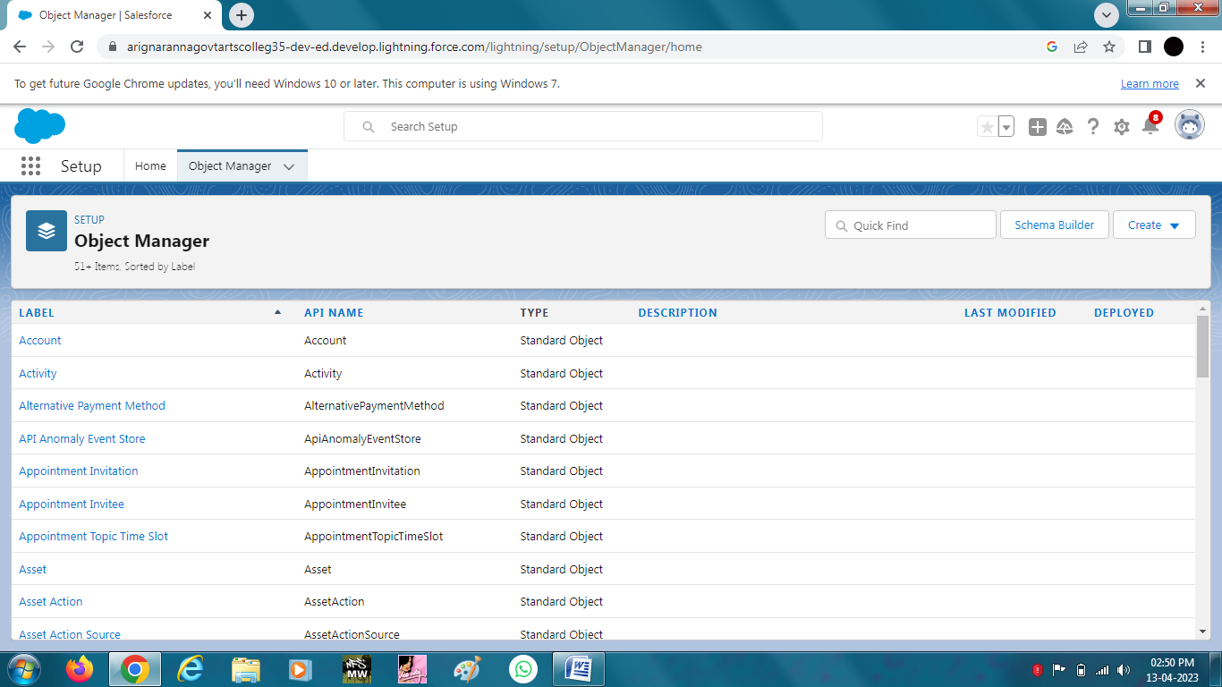

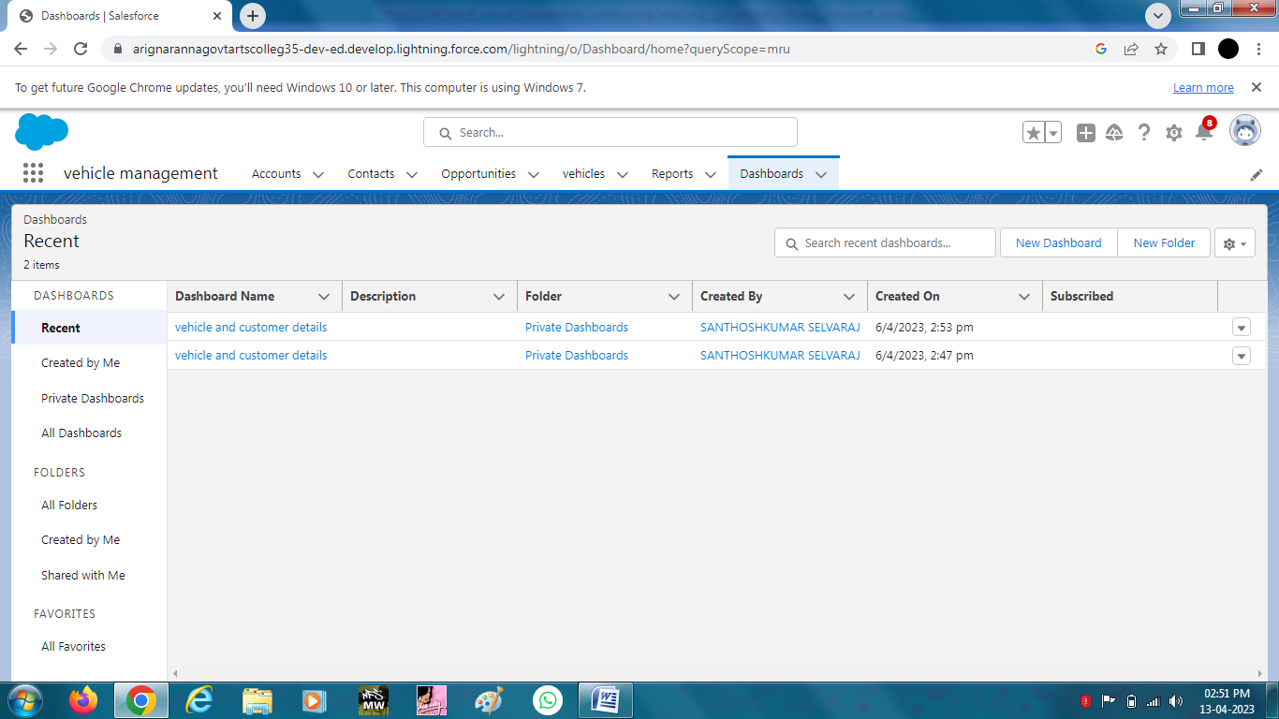
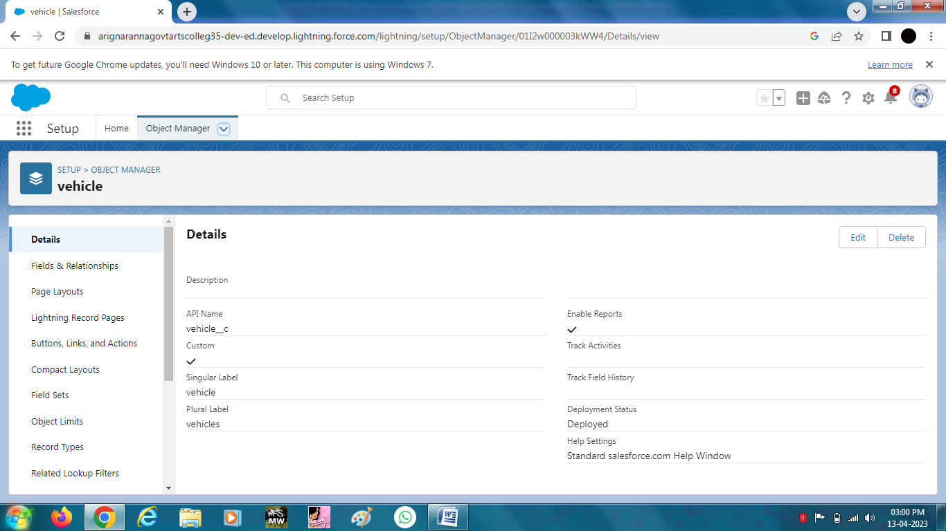
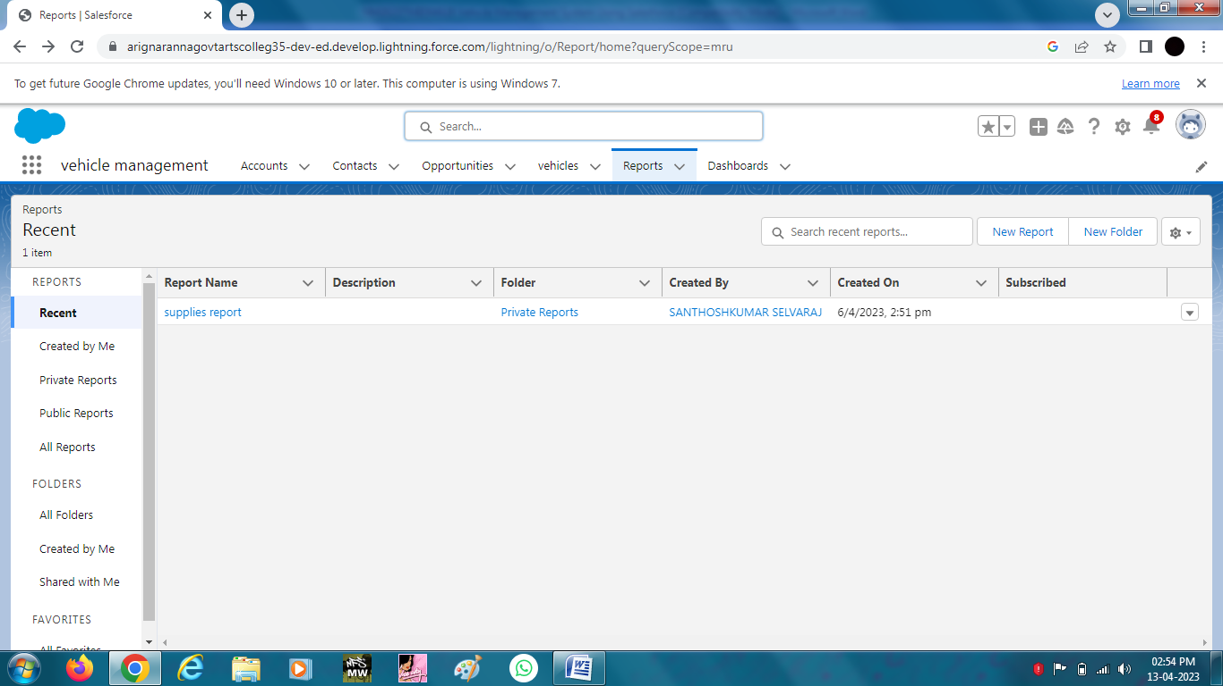

Trailhead Profile Public URL
Team Lead
https://trailblazer.me/id/pnallasamy
Team Member 1
https://trailblazer.me/id/madhs48

Team Member 2

https://trailblazer.me/id/sselvaraj87

Team Member 3

https://trailblazer.me/id/parthipanaagac

ADVANTAGES & DISADVANTAGE
List of advantages

- A vehicle management provides trips information such as fast acceleration.
- Improve the fleet safety and working conditions.
List of disadvantages
- It not much supported for uneducated peoples.
- Electricity storage is still expensive.

APPLICATIONS
- VMS is an application for the Automotive industry.
- It supports in the area of sales and service.
- It has security is taken to the highest level.
- CONCLUSION

This Project helps for place the order to purchase cars, bikes and
commercial vehicles.

FUTURE SCOPE
It can be developed in different languages and pictorial basis even for understanding uneducated peoples

